***NAME: KIRAN M***

***REG NO: 41120094***

***ROLL NO:21S121013***

***VIRTUAL VISIT TO INDIAN PILGRIMAGE***

***Problem statement:***

I am developing a website which will help the people to gain a experience of virtual visit to various pilgrimage places in India.

***Solution:***

I am implementing 360° view images connected, so everyone will get the view from all sides.

***Language:***

I use html for creating the website for this virtual visit to Indian pilgrimage.

***Future scope:***

* Implement a lot of pilgrimage sites of India.
  + - Also to trying to increase its scalability.
    - Establish in VR mode experience.

***Marketing strategy:***

* + - Promotes various advertisements on our websites.
    - Increase the revenue of the pilgrimage site.
    - Premium experience for pro members.

***Block diagram:***

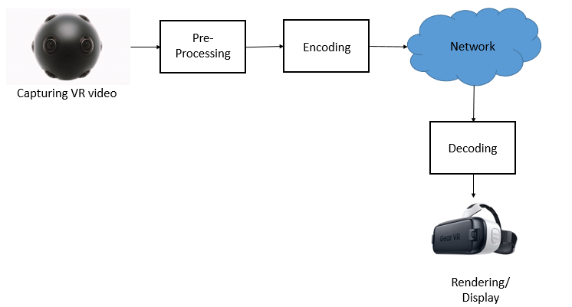

***Program:***

<!DOCTYPE html>

<html lang="en">

    <head>

        <meta charset="utf-8">

        <title>

            virtual tour to Indian pilgrimage

        </title>

    </head>

    <style>

        a {

            color: #000 !important;

        }

    </style>

    <body background="C:\Users\DTS\Desktop\fog-4529616__340.jpg" style="background-repeat:no-repeat; background-size:100%100%">

        <br/>

        <h3 align="center">

        <font face="Lato" color="#FF0000" size="6">KIRAN</font>

        &nbsp;&nbsp;&nbsp;&nbsp;&nbsp;&nbsp;&nbsp;&nbsp;&nbsp;&nbsp;&nbsp;&nbsp;&nbsp;&nbsp;&nbsp;&nbsp;&nbsp;&nbsp;&nbsp;&nbsp;

        &nbsp;&nbsp;&nbsp;&nbsp;&nbsp;&nbsp;&nbsp;&nbsp;&nbsp;&nbsp;&nbsp;&nbsp;&nbsp;&nbsp;&nbsp;&nbsp;&nbsp;&nbsp;&nbsp;&nbsp;

        &nbsp;&nbsp;&nbsp;&nbsp;&nbsp;&nbsp;&nbsp;&nbsp;&nbsp;&nbsp;&nbsp;&nbsp;&nbsp;&nbsp;&nbsp;&nbsp;&nbsp;&nbsp;&nbsp;&nbsp;

        &nbsp;&nbsp;&nbsp;&nbsp;&nbsp;&nbsp;&nbsp;&nbsp;&nbsp;&nbsp;&nbsp;&nbsp;&nbsp;&nbsp;&nbsp;&nbsp;&nbsp;&nbsp;&nbsp;&nbsp;

        &nbsp;&nbsp;&nbsp;&nbsp;&nbsp;&nbsp;&nbsp;&nbsp;&nbsp;&nbsp;&nbsp;&nbsp;&nbsp;&nbsp;&nbsp;&nbsp;&nbsp;&nbsp;&nbsp;&nbsp;

        &nbsp;&nbsp;&nbsp;&nbsp;&nbsp;&nbsp;&nbsp;&nbsp;&nbsp;&nbsp;&nbsp;&nbsp;&nbsp;&nbsp;&nbsp;&nbsp;&nbsp;&nbsp;&nbsp;&nbsp;

        &nbsp;&nbsp;&nbsp;&nbsp;&nbsp;&nbsp;&nbsp;&nbsp;&nbsp;&nbsp;&nbsp;&nbsp;&nbsp;&nbsp;&nbsp;&nbsp;&nbsp;&nbsp;&nbsp;&nbsp;

        <font face="cinzel" >

            &nbsp;&nbsp;&nbsp;<a href="#">HOME</a>&nbsp;&nbsp;&nbsp;

            <a href="#">IMAGES</a>&nbsp;&nbsp;&nbsp;

            <a href="#">VIDEOS</a>&nbsp;&nbsp;&nbsp;

            <a href="#">ABOUT US</a>&nbsp;&nbsp;&nbsp;

        </font>

        <br /><br /><br /><br /><br />

        <h1 align ="center">

            <font face="Lato" color="#800080" size="7">

                VIRTUAL TOUR TO INDIAN PILGRIMAGES

            </font>

        </h1>

        <h3 align=""center">

            <h1 align ="center">

                <font face="Lato" color="#FF0000" size="5">

                    360° virtual

                </font>

            </h3>

            &nbsp;&nbsp;&nbsp;&nbsp;&nbsp;&nbsp;&nbsp;&nbsp;&nbsp;&nbsp;&nbsp;&nbsp;&nbsp;&nbsp;&nbsp;&nbsp;&nbsp;&nbsp;&nbsp;&nbsp;

            <h1 align="left">

            &nbsp;&nbsp;&nbsp;&nbsp;&nbsp;&nbsp;&nbsp;&nbsp;&nbsp;&nbsp;&nbsp;&nbsp;&nbsp;&nbsp;&nbsp;

            <img src="C:\Users\DTS\Desktop\img1.jpg" height="200" width="300">

            &nbsp;&nbsp;&nbsp;&nbsp;&nbsp;&nbsp;&nbsp;&nbsp;&nbsp;&nbsp;&nbsp;&nbsp;&nbsp;&nbsp;&nbsp;&nbsp;&nbsp;&nbsp;&nbsp;

            <img src="C:\Users\DTS\Desktop\img2.png" height="200" width="300">

            &nbsp;&nbsp;&nbsp;&nbsp;&nbsp;&nbsp;&nbsp;&nbsp;&nbsp;&nbsp;&nbsp;&nbsp;&nbsp;&nbsp;&nbsp;&nbsp;&nbsp;&nbsp;&nbsp;

            <img src="C:\Users\DTS\Desktop\img3.jpg" height="200" width="300">

            </h1>

            <font face="cinzel">

            &nbsp;&nbsp;&nbsp;&nbsp;&nbsp;&nbsp;&nbsp;&nbsp;&nbsp;&nbsp;&nbsp;&nbsp;&nbsp;&nbsp;&nbsp;&nbsp;&nbsp;&nbsp;&nbsp;&nbsp;&nbsp;&nbsp;&nbsp;&nbsp;&nbsp;&nbsp;

            &nbsp;&nbsp;&nbsp;<font face="Lato" color="#000000" size="5"> <a href="https://www.360cities.net/image/kshameshwar-ghat">Kshameshwar Ghat (Varanasi)</a>

            &nbsp;&nbsp;&nbsp;&nbsp;&nbsp;&nbsp;&nbsp;&nbsp;&nbsp;&nbsp;&nbsp;&nbsp;&nbsp;&nbsp;&nbsp;&nbsp;&nbsp;&nbsp;&nbsp;&nbsp;&nbsp;&nbsp;&nbsp;&nbsp;&nbsp;&nbsp;

    &nbsp;&nbsp;<font face="Lato" color="#000000" size="5"> <a href="https://www.360cities.net/image/neelkanth-mahadev-temple-the-world">Neelkanth Mahadev(Haridwar)</a>

            &nbsp;&nbsp;&nbsp;&nbsp;&nbsp;&nbsp;&nbsp;&nbsp;&nbsp;&nbsp;&nbsp;&nbsp;&nbsp;&nbsp;&nbsp;&nbsp;&nbsp;&nbsp;&nbsp;&nbsp;&nbsp;&nbsp;&nbsp;&nbsp;

            &nbsp&nbsp;&nbsp;&nbsp;&nbsp;<font face="Lato" color="#00FFFF" size="5"> <a href=https://www.360cities.net/image/perutu-tirupati>Tirupati(Andhra Pradesh)</a>

            </font>

            <br/><br/><br/><br/>

            </font>

    </h3>

    &nbsp;&nbsp;&nbsp;&nbsp;&nbsp;&nbsp;&nbsp;&nbsp;&nbsp;&nbsp;&nbsp;&nbsp;&nbsp;&nbsp;&nbsp;&nbsp;&nbsp;&nbsp;&nbsp;&nbsp;

    <h1 align="left">

    &nbsp;&nbsp;&nbsp;&nbsp;&nbsp;&nbsp;&nbsp;&nbsp;&nbsp;&nbsp;

    <img src="C:\Users\DTS\Desktop\img4.jpg" height="200" width="300">

    &nbsp;&nbsp;&nbsp;&nbsp;&nbsp;&nbsp;&nbsp;&nbsp;&nbsp;&nbsp;&nbsp;&nbsp;&nbsp;

    <img src="C:\Users\DTS\Desktop\img5.jpg" height="200" width="300">

    &nbsp;&nbsp;&nbsp;&nbsp;&nbsp;&nbsp;&nbsp;&nbsp;&nbsp;&nbsp;&nbsp;&nbsp;

    <img src="C:\Users\DTS\Desktop\img6.jpg" height="200" width="300">

    </h1>

    <font face="cinzel">

    &nbsp;&nbsp;&nbsp;&nbsp;&nbsp;&nbsp;&nbsp;&nbsp;&nbsp;&nbsp;&nbsp;&nbsp;&nbsp;&nbsp;&nbsp;&nbsp;&nbsp;&nbsp;&nbsp;&nbsp;&nbsp;&nbsp;&nbsp;&nbsp;&nbsp;&nbsp;

    &nbsp;&nbsp;&nbsp;<font face="Lato" color="#000000" size="5"> <a href=https://www.360cities.net/image/pagal-baba>Madhura(Vridhavan)</a>

    &nbsp;&nbsp;&nbsp;&nbsp;&nbsp;&nbsp;&nbsp;&nbsp;&nbsp;&nbsp;&nbsp;&nbsp;&nbsp;&nbsp;&nbsp;&nbsp;&nbsp;&nbsp;&nbsp;&nbsp;&nbsp;&nbsp;&nbsp;&nbsp;&nbsp;&nbsp;

&nbsp;&nbsp;<font face="Lato" color="#000000" size="5"> <a href="https://www.360cities.net/image/minakshi-1">Meenakshiamman Temple(Madurai)</a>

    &nbsp;&nbsp;&nbsp;&nbsp;&nbsp;&nbsp;&nbsp;&nbsp;&nbsp;&nbsp;&nbsp;&nbsp;&nbsp;&nbsp;&nbsp;&nbsp;&nbsp;&nbsp;&nbsp;&nbsp;&nbsp;&nbsp;&nbsp;&nbsp;

&nbsp;&nbsp;&nbsp;&nbsp;&nbsp;<font face="Lato" color="#00FFFF" size="5"> <a href="https://www.360cities.net/image/golden-temple-amritsar">Golden Temple(Amritsar)</a>

    </font>

    <br/><br/><br/>

  </body>

</html>

***Website:***

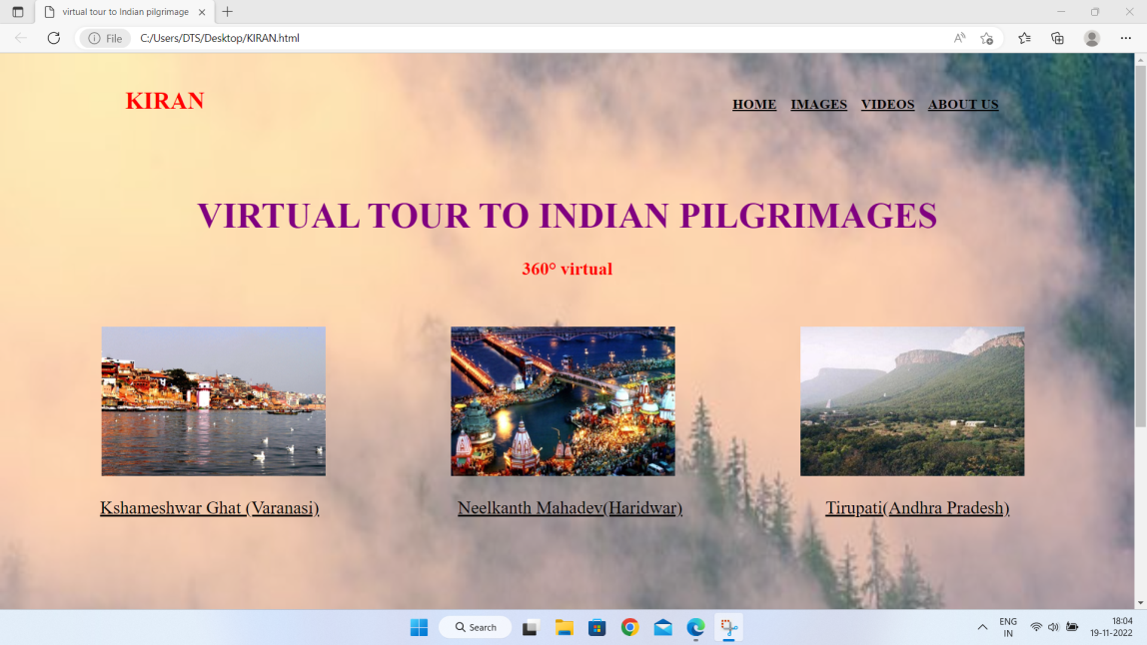

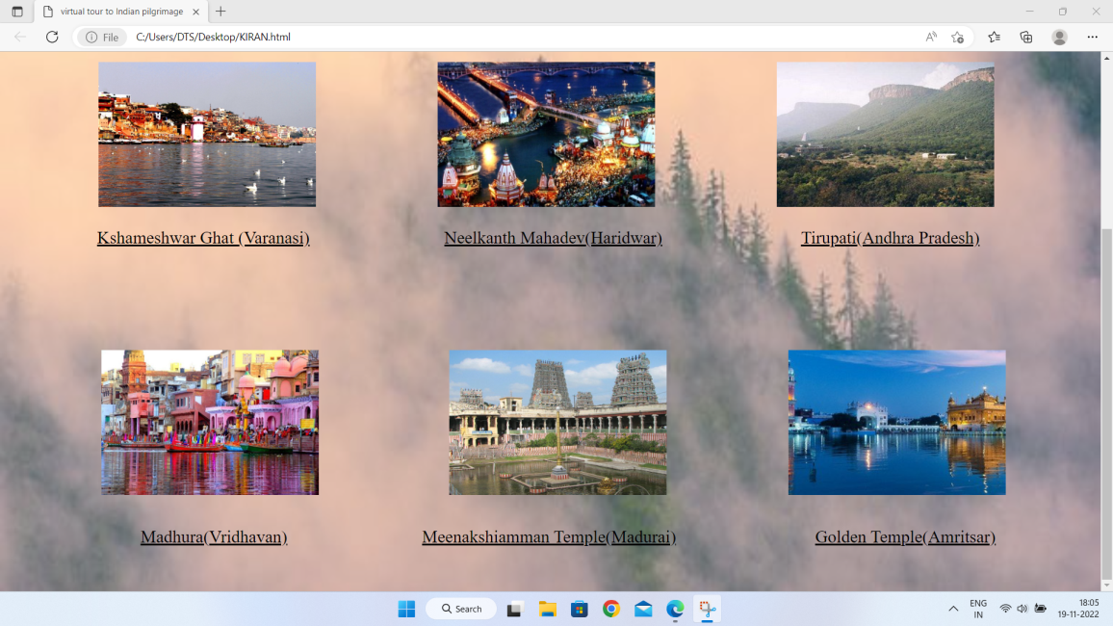

If we click in the names of the places under the images it will show the 360° view of the places in that images.

***Example pictures:***

